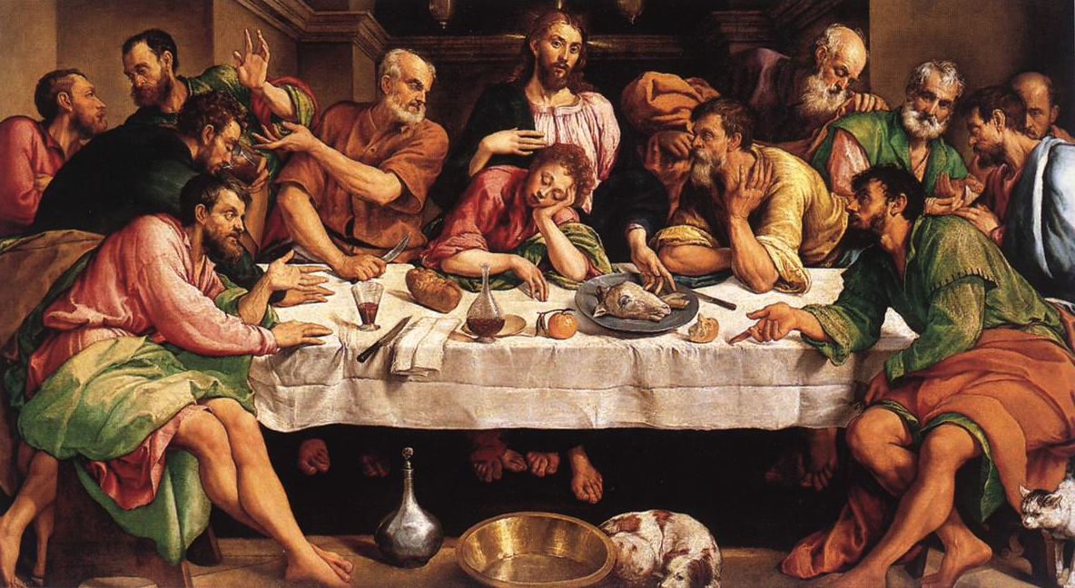

The main themes of the Last Supper
Matthew 26: 17–30
¹⁷ On the first day of the Festival of Unleavened Bread, the disciples came to Jesus and asked, “Where do you want us to make preparations for you to eat the Passover?”
¹⁸ He replied, “Go into the city to a certain man and tell him, ‘The Teacher says: My appointed time is near. I am going to celebrate the Passover with my disciples at your house.’” ¹⁹ So the disciples did as Jesus had directed them and prepared the Passover.
²⁰ When evening came, Jesus was reclining at the table with the Twelve. ²¹ And while they were eating, he said,“Truly I tell you, one of you will betray me.”
²² They were very sad and began to say to him one after the other, “Surely you don’t mean me, Lord?”
²³ Jesus replied, “The one who has dipped his hand into the bowl with me will betray me. ²⁴ The Son of Man will go just as it is written about him. But woe to that man who betrays the Son of Man! It would be better for him if he had not been born.”
²⁵ Then Judas, the one who would betray him, said, “Surely you don’t mean me, Rabbi?”
Jesus answered, “You have said so.”
²⁶ While they were eating, Jesus took bread, and when he had given thanks, he broke it and gave it to his disciples, saying, “Take and eat; this is my body.”
²⁷ Then he took a cup, and when he had given thanks, he gave it to them, saying, “Drink from it, all of you. ²⁸ This is my blood of the^{[a]} covenant, which is poured out for many for the forgiveness of sins. ²⁹ I tell you, I will not drink from this fruit of the vine from now on until that day when I drink it new with you in my Father’s kingdom.”
³⁰ When they had sung a hymn, they went out to the Mount of Olives.
The main themes of the Last Supper

Class discussion: Use the notes scribed onto the whiteboard about the themes listed below to assist your final response:

- Liberation and Redemption: In the same way that Passover celebrates God’s redemption of his people through the Exodus experience, the Matthean Jesus’ final supper celebrates what will be God’s act of liberation and redemption to be realised in the death and resurrection in the following days.

We are liberated and redeemed from sin through Christ’s death and resurrection. Why do you believe this to be so?

________________________________________________________________________________________________________________________________________________________________________________________________________________________________________________________________________________________________________________________________________________________________________________________________________________________________________________________________________________________________

- New Covenant: The first covenant of Sinai was sealed symbolically with blood and was celebrated with a meal and sacrifices. The new covenant is sealed through the Body and Blood of Jesus and is celebrated with a sacrificial meal.

How is Jesus Christ the ‘New Covenant’?
________________________________________________________________________________________________________________________________________________________________________________________________________________________________________________________________________________________________________________________________________________________________________________________________________________________________________________________________________________________________

- Blessing: Jesus’ actions during the Last Supper are similar to those performed at the Jewish Sabbath and holiday meals. Jesus performs a blessing or thanksgiving saying words similar to: ‘Blessed are you, Lord our God, King of the universe, who brings bread from the earth… Blessed are you creator of the vine…’

Why do you think Jesus performs a blessing/thanksgiving prayer before the meal?
________________________________________________________________________________________________________________________________________________________________________________________________________________________________________________________________________________________________________________________________________________________________________________________________________________________________________________________________________________________________

- Meal: There are also practices and symbolic actions used throughout this meal.

• Dipping: The practice of sharing food was part of the Passover ritual. Judas ignores the ‘leadership’ of Jesus by dipping into the bowl first. The betrayer violates the bond of those who celebrate Passover together.

• Take and eat: Jesus gives new meaning to actions customary at Jewish meals – sharing the loaf of bread and cup of wine. Sharing in Jesus’ bread means sharing in his death.

How do the symbolic actions we perform during the Mass give meaning to our participation in the sacrament of the Eucharist?
________________________________________________________________________________________________________________________________________________________________________________________________________________________________________________________________________________________________________________________________________________________________________________________________________________________________________________________________________________________________

