Methods of Biblical Analysis | Mark 4: 30-32 | Placing Biblical Passages in Context
4. Moral Sense:  In what way does this text lead me towards change?  3. Anagogical Sense:  What does this text have to do with my life? (Ethical Implications)  1. Literal Sense:  What does this text say plainly?  2. Allegorical Sense:  What do we learn about Christ from reading the text? | 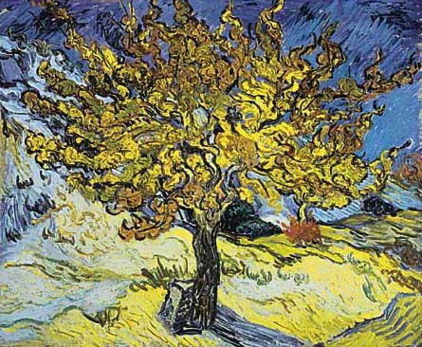  The main text  The Parable of the Mustard Seed  ³⁰Again he said, "What shall we say the kingdom of God is like, or what parable shall we use to describe it? ³¹It is like a mustard seed, which is the smallest seed you plant in the ground. ³²Yet when planted, it grows and becomes the largest of all garden plants, with such big branches that the birds of the air can perch in its shade." | The text before  The Parable of the Growing Seed  ²⁶ He also said, “This is what the kingdom of God is like. A man scatters seed on the ground. ²⁷ Night and day, whether he sleeps or gets up, the seed sprouts and grows, though he does not know how. ²⁸ All by itself the soil produces grain—first the stalk, then the head, then the full kernel in the head. ²⁹ As soon as the grain is ripe, he puts the sickle to it, because the harvest has come.”  The text afterward  Jesus Calms the Storm  ³⁵ That day when evening came, he said to his disciples, “Let us go over to the other side.” ³⁶ Leaving the crowd behind, they took him along, just as he was, in the boat. There were also other boats with him. ³⁷ A furious squall came up, and the waves broke over the boat, so that it was nearly swamped. ³⁸ Jesus was in the stern, sleeping on a cushion. The disciples woke him and said to him, “Teacher, don’t you care if we drown?”  ³⁹ He got up, rebuked the wind and said to the waves, “Quiet! Be still!”Then the wind died down and it was completely calm.  ⁴⁰ He said to his disciples, “Why are you so afraid? Do you still have no faith?”  ⁴¹ They were terrified and asked each other, “Who is this? Even the wind and the waves obey him!”

