Methods of Biblical Analysis | Mark 4: 26-29 | Placing Biblical Passages in Context
4. Moral Sense:  In what way does this text lead me towards change?  3. Anagogical Sense:  What does this text have to do with my life? (Ethical Implications)  1. Literal Sense:  What does this text say plainly?  2. Allegorical Sense:  What do we learn about Christ from reading the text? | 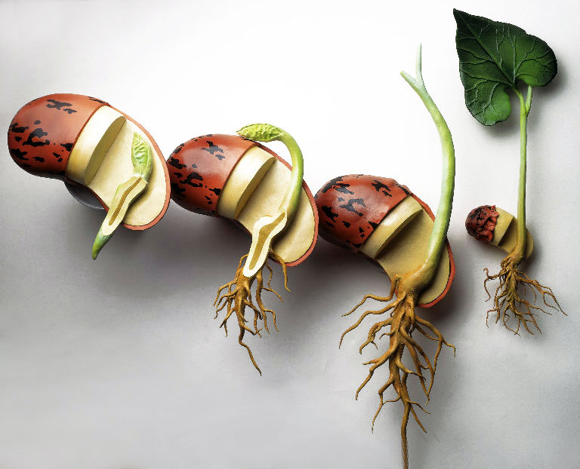  The main text  The Parable of the Growing Seed  ²⁶He also said, "This is what the kingdom of God is like. A man scatters seed on the ground. ²⁷Night and day, whether he sleeps or gets up, the seed sprouts and grows, though he does not know how. ²⁸All by itself the soil produces grain—first the stalk, then the head, then the full kernel in the head. ²⁹As soon as the grain is ripe, he puts the sickle to it, because the harvest has come." | The text before  A Lamp on a Stand  ²¹ He said to them, “Do you bring in a lamp to put it under a bowl or a bed? Instead, don’t you put it on its stand? ²² For whatever is hidden is meant to be disclosed, and whatever is concealed is meant to be brought out into the open. ²³ If anyone has ears to hear, let them hear.”  ²⁴ “Consider carefully what you hear,” he continued. “With the measure you use, it will be measured to you—and even more. ²⁵ Whoever has will be given more; whoever does not have, even what they have will be taken from them.”  The text afterward  The Parable of the Mustard Seed  ³⁰ Again he said, “What shall we say the kingdom of God is like, or what parable shall we use to describe it? ³¹ It is like a mustard seed, which is the smallest of all seeds on earth. ³² Yet when planted, it grows and becomes the largest of all garden plants, with such big branches that the birds can perch in its shade.”  ³³ With many similar parables Jesus spoke the word to them, as much as they could understand. ³⁴ He did not say anything to them without using a parable. But when he was alone with his own disciples, he explained everything.

