Eucharist – the Living Body of Christ

Matthew 18:20
For where two or three are gathered in my name, I am there among them.’

Corinthians 12:12-15 - One Body with Many Members

For just as the body is one and has many members, and all the members of the body, though many, are one body, so it is with Christ. For in the one Spirit we were all baptized into one body—Jews or Greeks, slaves or free—and we were all made to drink of one Spirit. Indeed, the body does not consist of one member but of many. If the foot were to say, ‘Because I am not a hand, I do not belong to the body’, that would not make it any less a part of the body.

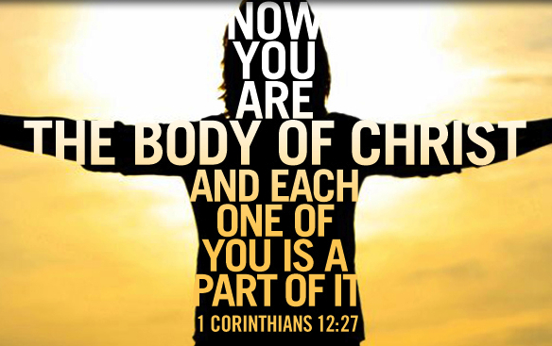

Using the scriptural passages above explain how we are the body of the Church and Christ is the head.
________________________________________________________________________________________________________________________________________________________________________________________________________________________________________________________________________________________________________________________________________________________________________________________________________________________________________________________________________________________________________________________________________________________________________________________________________________________________________________________________

