Christian Beliefs

Use the work sheet as well as [www.religionfacts.com/christianity](http://www.religionfacts.com/christianity) & <http://www.mnsu.edu/emuseum/cultural/religion/christianity/beliefs.html> to help you fill in the table.

|  |  |  |
| --- | --- | --- |
| Beliefs | Explanation | Visual Representation |
| God | -Belief in one god  -Jesus Christ is the son of god  -God sent his son on earth to save humanity from the consequences of its sins | [http://t1.gstatic.com/images?q=tbn:YlZlg4UfCsaJDM:http://www.alicebot.org/images/god2.jpg](http://images.google.com.au/imgres?imgurl=http://www.alicebot.org/images/god2.jpg&imgrefurl=http://www.alicebot.org/oldnews2007.html&usg=__uhjMhTt--1IPhqtLq-GZHYZiSNA=&h=1080&w=771&sz=272&hl=en&start=2&itbs=1&tbnid=YlZlg4UfCsaJDM:&tbnh=150&tbnw=107&prev=/images?q=god&hl=en&sa=G&gbv=2&tbs=isch:1) |
| The Trinity | Trinity- that is god exists as father, son and holy spirit  Through the work of the holy spirit god is present with us today | C:\Users\n.bilaver\AppData\Local\Microsoft\Windows\Temporary Internet Files\Content.IE5\JXV9MRX8\MCj01565210000[1].wmf |
| Jesus Christ | Jesus was fully human & the son of god  Through his death & resurrection- forgiveness was made | C:\Users\n.bilaver\AppData\Local\Microsoft\Windows\Temporary Internet Files\Content.IE5\DI2MK8EE\MCj00980930000[1].wmf |
| The Holy Spirit | The holy spirit is the third person of the trinity- equal with the father & the son | C:\Users\n.bilaver\AppData\Local\Microsoft\Windows\Temporary Internet Files\Content.IE5\ASF3Z7LF\MCSY01650_0000[1].wmf |
| Angels and Demons | Belief in angelic beings- they are spiritual beings who were created by god before the world was created  Also a strong belief in saints | C:\Users\n.bilaver\AppData\Local\Microsoft\Windows\Temporary Internet Files\Content.IE5\08P8ANPF\MCj04370120000[1].wmf |
| Doctrine of Mary | Mother of jesus (immaculate conception0  The focus of much devotion | C:\Users\n.bilaver\AppData\Local\Microsoft\Windows\Temporary Internet Files\Content.IE5\DI2MK8EE\MCj04126960000[1].wmf |
| Human Nature | Belief that humans were created in the image of god  But has fallen from its original state due to sin | C:\Users\n.bilaver\AppData\Local\Microsoft\Windows\Temporary Internet Files\Content.IE5\JXV9MRX8\MCPE07654_0000[1].wmf |
| Salvation | The church & its believers are necessary for salvation (a process where human beings are saved or brought to fullness of life in god)  Jesus is central to salvation through his death | C:\Users\n.bilaver\AppData\Local\Microsoft\Windows\Temporary Internet Files\Content.IE5\ASF3Z7LF\MCj01560730000[1].wmf |
| The afterlife | Vast majority believe in an afterlife following death   * There is Some belief in heaven where god’s presence is evident | C:\Users\n.bilaver\AppData\Local\Microsoft\Windows\Temporary Internet Files\Content.IE5\ASF3Z7LF\MCj02805010000[1].wmf |
| Hell | Hell is the place or state into which unrepentant sinners pass after this life  Involves the pain of separation from god | C:\Users\n.bilaver\AppData\Local\Microsoft\Windows\Temporary Internet Files\Content.IE5\JXV9MRX8\MCj04359310000[1].wmf |
| Christian Views of Other Religions | The modern age has a strong tolerance and acceptance of a wide variety of religions | C:\Users\n.bilaver\AppData\Local\Microsoft\Windows\Temporary Internet Files\Content.IE5\JXV9MRX8\MCj03536470000[1].wmf |
| Sacraments | Jesus established the sacraments- the main 2 are baptism and the eucharist |  |

The beliefs of Christianity can also be seen in the words of the Apostles' Creed, a document which was written to distinguish Christianity from other religions and show basic Christian doctrine in a concise manner

**The Apostle's Creed**

I believe in God the Father Almighty,  
Maker of heaven and earth.   
And in Jesus Christ,   
His only Son, our Lord;   
Who was conceived by the Holy Spirit,  
Born of the Virgin Mary,  
Suffered under Pontius Pilate,  
Was crucified, died and was buried.   
He descended into hell;  
The third day He rose again from the dead;  
He ascended into heaven   
and is seated at the right hand of God the Father Almighty;  
From there He shall come to judge the living and the dead.   
I believe in the Holy Spirit,  
The holy Christian Church,  
The Communion of Saints,  
the Forgiveness of sins,   
The Resurrection of the body,  
And the Life everlasting.   
Amen.

What are the Christian denominations?

Today there are a number of different Christian denominations…an easy way to understand this concept is outlined in a table below

**Christian Denominations**

|  |  |  |
| --- | --- | --- |
| **Catholic Churches**  **(East)** | **Non Catholic Churches (East)** | **Other Christian Churches**  **(West)** |
| Armenian Catholic Church | Orthodox | Protestant |
| Caldean & Assyrian Catholic Church | *Greek Orthodox Church* | *Baptist* |
| Melkite Greek Catholic Church | *Russian Orthodox Church* | *Lutheran* |
| Ukranian Greek Catholic Church | *Ukrainian Orthodox Church* | *Uniting Church* |
| Russian Catholic Church | *Coptic Orthodox Church* | Anglican |
| Maronite Catholic Church | *Armenian Orthodox Church* | Presbyterian |
| Syrian Catholic Church | *Antiochian Orthodox Church* | Pentecostal |
|  | *Syrian Orthodox Church* | *Salvation Army* |
|  |  | **Roman Catholic** |

In the next part of the unit, we will do an investigation into the following denominations: Anglican, Lutheran, Orthodox & Catholic Traditions

Use the following headings to gather information on your denomination:

* Major Beliefs
* Sacraments
* Central head of the Church
* Key teachings
* The founder
* Sacred text
* Any other information

How did these denominations come about?

Read pages 113-116 ofKWL and answer the following:

The schism (or spilt)

In dot points, what are the reasons for which the Christian Churches split from each other

Use the information to summarise the main differences between the Eastern and Western Churches

|  |  |  |
| --- | --- | --- |
|  | Eastern | Western |
| Leader |  |  |
| Language |  |  |
| Centre of authority |  |  |
| Celebration of the Eucharist |  |  |
| Holy images/icons |  |  |
| Priests celibacy |  |  |
| Nicene Creed |  |  |

In the next part of the unit, we will do an investigation into the following denominations: Anglican, Lutheran, Orthodox & Catholic Traditions

Use the following headings to gather information on your denomination:

Major Beliefs

Sacraments

Central head of the Church

Key teachings

The founder

Sacred text

Any other information

**A Comparative Chart of Christian Beliefs**

|  |  |  |  |  |  |  |  |
| --- | --- | --- | --- | --- | --- | --- | --- |
| **Catholic Beliefs** | **Eastern Orthodox** | **Lutherans** | **Baptists** | **Anglicans** | **Methodists** | **Presbyterians** | **Evangelicals** |
| **Trinity** | **WB01518_.gif (392 bytes)** | **WB01518_.gif (392 bytes)** | **WB01518_.gif (392 bytes)** | **WB01518_.gif (392 bytes)** | **WB01518_.gif (392 bytes)** | **WB01518_.gif (392 bytes)** | **WB01518_.gif (392 bytes)** |
| **Belief in Christ's redemptive death** | **WB01518_.gif (392 bytes)** | **WB01518_.gif (392 bytes)** | **WB01518_.gif (392 bytes)** | **WB01518_.gif (392 bytes)** | **WB01518_.gif (392 bytes)** | **WB01518_.gif (392 bytes)** | **WB01518_.gif (392 bytes)** |
| **Jesus is both God and man** | **WB01518_.gif (392 bytes)** | **WB01518_.gif (392 bytes)** | **WB01518_.gif (392 bytes)** | **WB01518_.gif (392 bytes)** | **WB01518_.gif (392 bytes)** | **WB01518_.gif (392 bytes)** | **WB01518_.gif (392 bytes)** |
| **Salvation by Grace (Catholic definition)** | **WB01518_.gif (392 bytes)** | **WB01518_.gif (392 bytes)** | **WB01371_.gif (289 bytes)** | **BD00028_.WMF (1026 bytes)** | **WB01371_.gif (289 bytes)** | **WB01371_.gif (289 bytes)** | **WB01371_.gif (289 bytes)** |
| **All men have the possiblity of salvation (against Calvin's predestination doctrine)** | **WB01518_.gif (392 bytes)** | **WB01518_.gif (392 bytes)** | **WB01518_.gif (392 bytes)** | **WB01518_.gif (392 bytes)** | **WB01518_.gif (392 bytes)** | **WB01371_.gif (289 bytes)** | **WB01518_.gif (392 bytes)** |
| **Belief in Sacrifice of the Mass** | **WB01518_.gif (392 bytes)** | **WB01371_.gif (289 bytes)** | **WB01371_.gif (289 bytes)** | **WB01518_.gif (392 bytes)** | **WB01371_.gif (289 bytes)** | **WB01371_.gif (289 bytes)** | **WB01371_.gif (289 bytes)** |
| **Denomination has a valid   ordination of Priests (as judged by the Catholic Church)** | **WB01518_.gif (392 bytes)** | **WB01371_.gif (289 bytes)** | **WB01371_.gif (289 bytes)** | **WB01371_.gif (289 bytes)** | **WB01371_.gif (289 bytes)** | **WB01371_.gif (289 bytes)** | **WB01371_.gif (289 bytes)** |
| **Denomination has a valid consecration of the Eucharist and belief in the Real Presence** | **WB01518_.gif (392 bytes)** | **WB01371_.gif (289 bytes)** | **WB01371_.gif (289 bytes)** | **WB01371_.gif (289 bytes)** | **WB01371_.gif (289 bytes)** | **WB01371_.gif (289 bytes)** | **WB01371_.gif (289 bytes)** |
| **Fidelity to the Pope as teacher of the Faith** | **WB01371_.gif (289 bytes)** | **WB01371_.gif (289 bytes)** | **WB01371_.gif (289 bytes)** | **WB01371_.gif (289 bytes)** | **WB01371_.gif (289 bytes)** | **WB01371_.gif (289 bytes)** | **WB01371_.gif (289 bytes)** |
| **Fidelity to the Pope as Apostolic Primate** | **WB01518_.gif (392 bytes)** | **WB01371_.gif (289 bytes)** | **WB01371_.gif (289 bytes)** | **WB01371_.gif (289 bytes)** | **WB01371_.gif (289 bytes)** | **WB01371_.gif (289 bytes)** | **WB01371_.gif (289 bytes)** |
| **Belief in the ability of the individual Christian to lose salvation** | **WB01518_.gif (392 bytes)** | **WB01518_.gif (392 bytes)** | **WB01371_.gif (289 bytes)** | **WB01518_.gif (392 bytes)** | **WB01371_.gif (289 bytes)** | **WB01371_.gif (289 bytes)** | **WB01371_.gif (289 bytes)** |
| **Belief in distinction of sin (mortal and venial)** | **WB01518_.gif (392 bytes)** | **BD00028_.WMF (1026 bytes)** | **WB01371_.gif (289 bytes)** | **WB01518_.gif (392 bytes)** | **WB01371_.gif (289 bytes)** | **WB01371_.gif (289 bytes)** | **WB01371_.gif (289 bytes)** |
| **Belief in equality of Holy Scripture and Holy Tradition (Deposit of Faith)** | **WB01518_.gif (392 bytes)** | **WB01371_.gif (289 bytes)** | **WB01371_.gif (289 bytes)** | **BD00028_.WMF (1026 bytes)** | **WB01371_.gif (289 bytes)** | **WB01371_.gif (289 bytes)** | **WB01371_.gif (289 bytes)** |
| **Adherence and recognition of all the Church's Ecumenical Councils** | **WB01371_.gif (289 bytes)** | **WB01371_.gif (289 bytes)** | **WB01371_.gif (289 bytes)** | **WB01371_.gif (289 bytes)** | **WB01371_.gif (289 bytes)** | **WB01371_.gif (289 bytes)** | **WB01371_.gif (289 bytes)** |
| **Bible canon contains 73 books including all seven books  in the Septuagint canon.** | BD00028_.WMF (1026 bytes) | WB01371_.gif (289 bytes) | WB01371_.gif (289 bytes) | BD00028_.WMF (1026 bytes) | WB01371_.gif (289 bytes) | WB01371_.gif (289 bytes) | WB01371_.gif (289 bytes) |
| **Baptism is normatively necessary for salvation.** | WB01518_.gif (392 bytes) | WB01518_.gif (392 bytes) | WB01371_.gif (289 bytes) | WB01518_.gif (392 bytes) | WB01371_.gif (289 bytes) | WB01371_.gif (289 bytes) | WB01371_.gif (289 bytes) |
| **Belief in all seven sacraments of the Church.** | WB01518_.gif (392 bytes) | WB01371_.gif (289 bytes) | WB01371_.gif (289 bytes) | WB01518_.gif (392 bytes) | WB01371_.gif (289 bytes) | WB01371_.gif (289 bytes) | WB01371_.gif (289 bytes) |

This table represents a general, sweeping overview of non-Catholic Christian beliefs and their comparison to the Catholic Church.  Protestantism, by definition, accepts private judgement of Scripture over Church authority (this happens to a lesser extent in Anglicanism and Lutheranism).  Therefore, it is difficult to pigeon-hole Protestant beliefs because of the resultant diversity of beliefs within denominations.  Nevertheless, the above table is a useful tool because it represents the majority opinion of that denomination.

The symbology of the table is fairly straightforward.  Checkmarks indicate agreement with the Catholic position and an "X" indicates a dissenting opinion.   Question marks indicate that the matter is either unresolved in that particular denomination, or that the doctrine in question cannot be sufficiently answered with a straight yes or no answer.  For instance, in the case of the Eastern Orthodox churchs they generally agree with the Catholic definition of the Biblical canon, but sometimes add additional books (such as Esdras III).



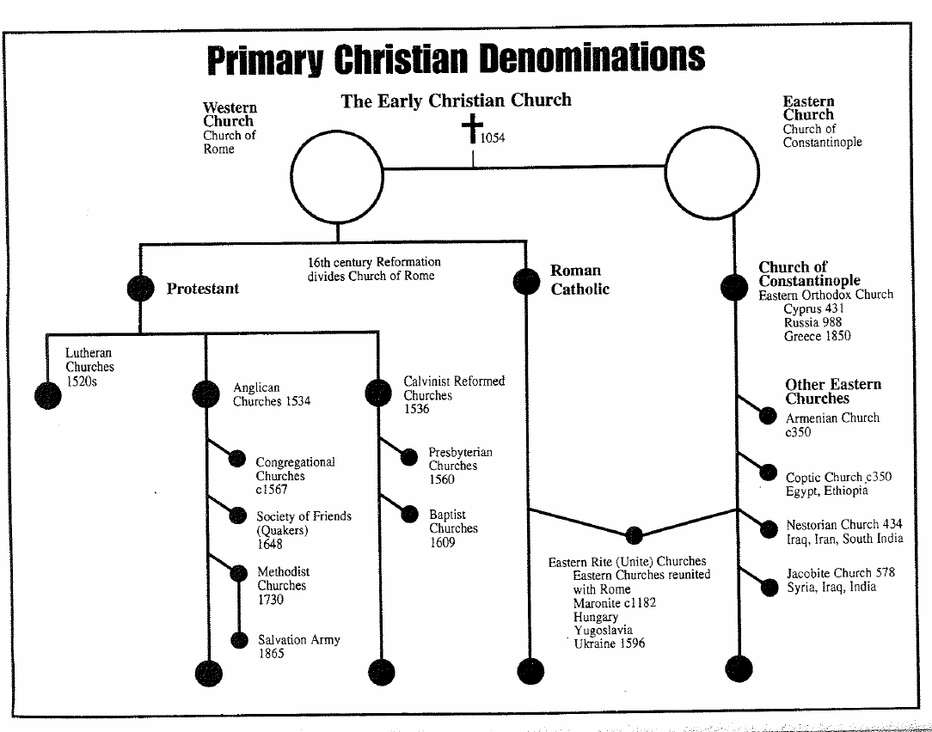

So what happened after the Schism (split)…movement to unity (ecumenism)

Read pages 117, 121, 122, 123 to develop a summary on the process of the need for unity among Christian denominations

How is ecumenism in action today within our Catholic Church?

World Council of Churches